WIKI System Start UP

Table of Contents
Procedure information 2
1. Reference documents 3
2. Bill of Materials needed 3
3. Terminologies 3
4. Zeroing Process Manometer 4
a. Zeroing using manometer Tuning Screw driver 4
b. Zeroing using Vat valve (indirect approach) 5
c. Confirming zeroing 6
5. External data logger 7
a. Settings for external triggering. 7
6. Appendix 10
a. Installing VAT VALVE Software (CPA) 10

Procedure information
Procedure # | VS_WIKI_1007_REVA
Initial Issue Date | 06-12-2021
Initial Edited by | Behnam Behziz
Last Edit Date | 06-12-2021
Last Edited by | Behnam Behziz
Affected systems | All
Expected Execution Time | 1 hours
Number of Operators Needed | 1 Person
Operator requirements | Technician level 1
Electrical Hazard | Non.
Mechanical Hazard | Non.
Chemical Hazard | Non.
Safety Control | Non.

Reference documents
- NA

Bill of Materials needed
- NA

Terminologies
- Manometer: gas pressure sensor

Zeroing Process Manometer
- Zeroing the manometer is possible through manometer tuning screw or through Vat valve program.
- For each system once both “a,b” needs to be done. After that, the zeroing can be done by using “a” only.

Zeroing using manometer Tuning Screw driver
    - Ensure the manometer is being turned on for more than 60 minutes. This ensures the PCBA is in thermal equal prior to hand-tuning the manometer.
    - Use HMI. Open up the Vat valve fully. Stop any gas flow to chamber.
    - Ensure the full-scale manometer is reading lower than 1 uTorr.
    - Measure the voltage between pin 2 and 12 (2 positive and 12 negative) using FLUKE voltmeter;
    - Record the voltage and pressure from HMI in table below.
    - Hand-tune the tuning screw in front of the manometer to reach to 0 as close as possible. (Absolute error smaller than 0.05V)
    - Measure new voltage between pin 2 and 12(2 positive and 12 negative); Record it in table below.
    - Record the pressure from HMI in table below.
    - Disconnect the FLUKE setup and connect back the cable.
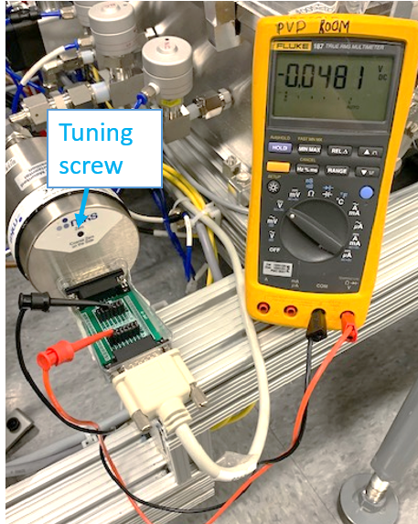

 | Before adjustment | After Adjustment
Voltage (pin 2&12)
Pressure

Zeroing using Vat valve (indirect approach)
- Ensure the manometer is being turned on for more than 60 minutes. This ensures the PCBA is in thermal equal prior to hand-tuning the manometer.
- Use HMI. Open up the Vat valve fully. Stop any gas flow to chamber.
- Locate VAT cable from red bin in electrical tool box.
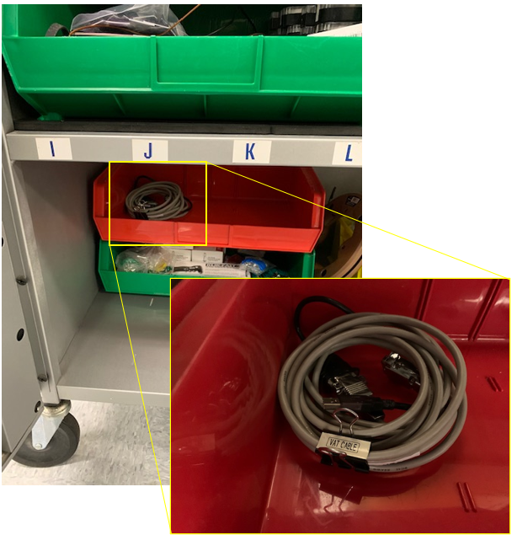
- Use the cable, and connect USB side to your computer and connect the Dsub side to service port of the VAT valve.
- Open CPA program to communicate to the VAT VALVE. If CPA program is not installed, please follow appendix (‎5).
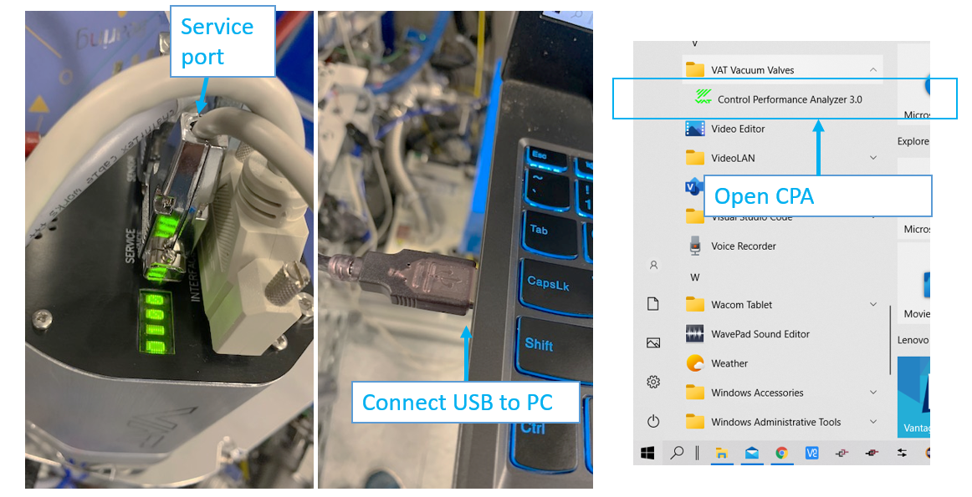
- The program will try to scan the VAT valve. Connect to correct port.
- From top left, click on the key symbol and ensure it is set to “Remote”.
- Navigate to Sensor > setup and enable zeroing.
- Navigate to Sensor > Zero and click on Zeroing.
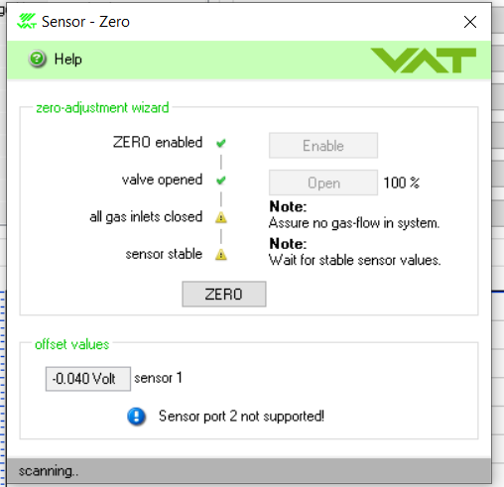
- Note that the absolute value of offset value is less than 0.05V.
- From top left, click on the key symbol and ensure it is set to “Local”.
- Disconnect service cable.

Confirming zeroing
    - Ensure the manometer is being turned on for more than 60 minutes. This ensures the PCBA is in thermal equal prior to hand-tuning the manometer.
    - Use table below as reference and fill out the readings. Consult with Engineer to ensure the numbers are acceptable.
    - For instance, for case 3, open the vat valve, flow gas to 10 SCCM, wait until the reading of flow stabilizes. Record the fine manometer reading. Record the full-scale manometer reading. Record the voltage reading from pin 2 and 12.
    - For instance, for case 7, flow gas to 10 SCCM, wait until reading of flow stabilizes. Set the pressure setting of vat valve to 3 mTorr. Wait until the reading of pressure stabilizes. Record the fine manometer reading. Record the full-scale manometer reading. Record the voltage reading from pin 2 and 12.

Case | Flow  (SSCM) | VAT VALVE  Pressure setpoint  (mTorr) | Fine Manometer  (mTorr) | Full Scale  Manometer  (Torr) | Voltage Reading  (V)
1 | 0 | Open
2 | 5 | Open
3 | 10 | Open
4 | 15 | Open
5 | 20 | Open
6 | 6 | 1.5
7 | 10 | 3
8 | 15 | 6

External data logger

Settings for external triggering.
- Ensure the datalogger is stopped by pressing stop if it is not grayed out.
- Select Capture settings to adjust the settings for external signal
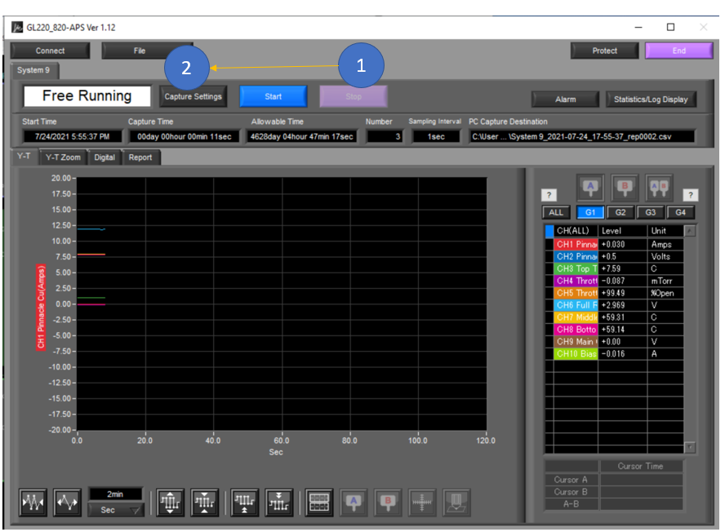

- Select “Trigger Alarm Settings” Tab
- Set Trigger start condition to “External”
- Set Trigger stop condition to “External”
- Set the repeat to “ON”
- Apply
- Ok. This forces the datalogger listen to external signal generated from HMI to triggering start/stop of datalogging.
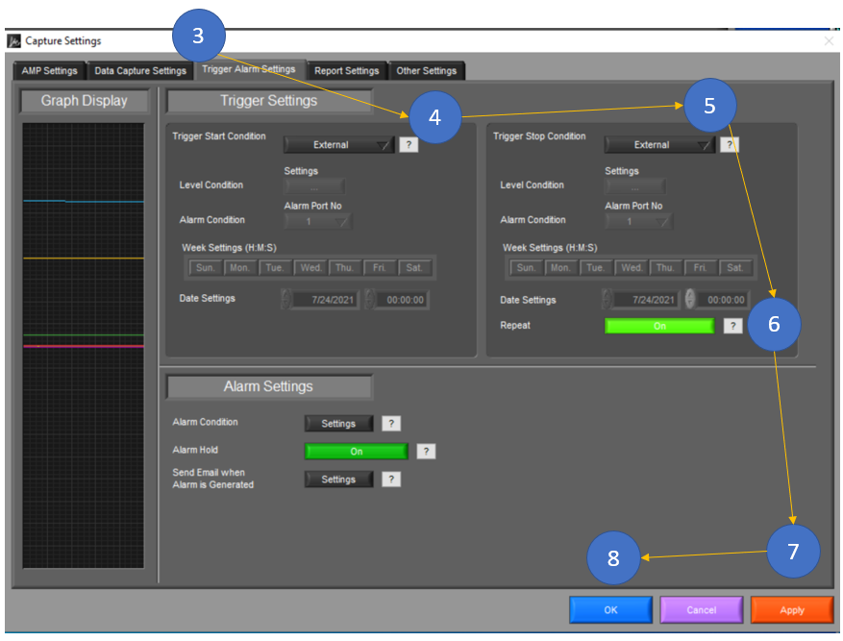

- Press start.
- Ensure the system goes to “Armed” mode. Now the datalogger is waiting for external signal to start recording or end recording. When HMI starts a recipe, it will send an external trigger to start recording and when the recipe completed, it will end the recording and saves it for future review.

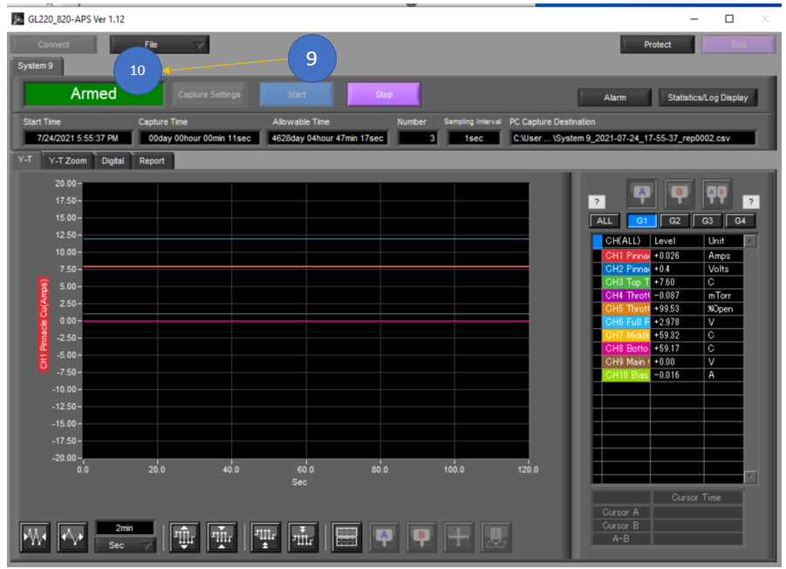

Appendix

Installing VAT VALVE Software (CPA)
  - Please install VAT Valve CPA software from this link.
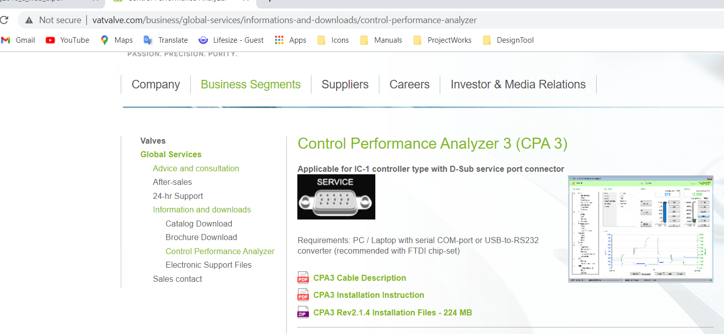
  - Follow the installation instruction from the link above.

